09/10/2020

CMP4271 Professional Practice for Games Development

Task 2

2.0 Introduction

Monopolisationis a Territorial Acquisition based upon Monoploy (<https://www.hasbro.com/common/instruct/00009.pdf>) . it is playable by 2-4 people with the aim being to take over as much territory as possible.

2.1 Materials

Game board (Fig 1) 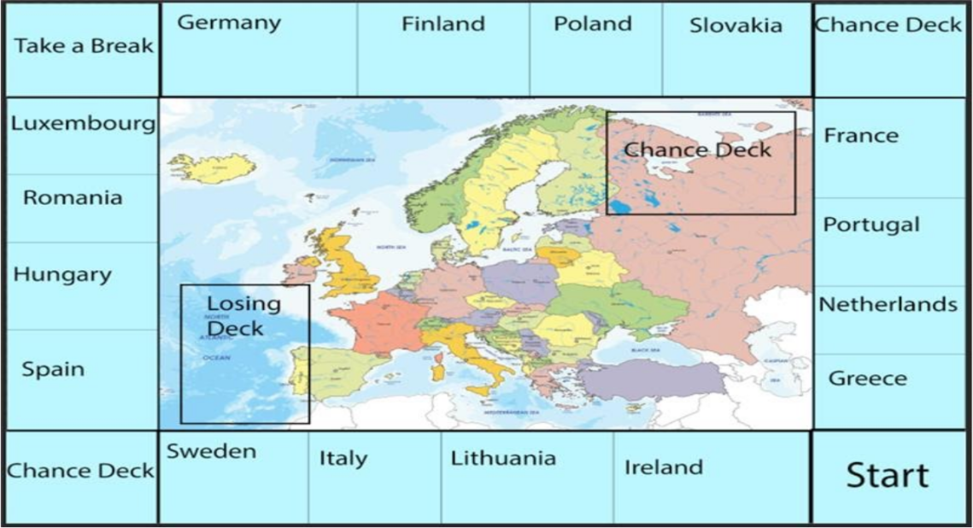

Player tokens

Cards that you claim when you buy a territory (Fig 2).

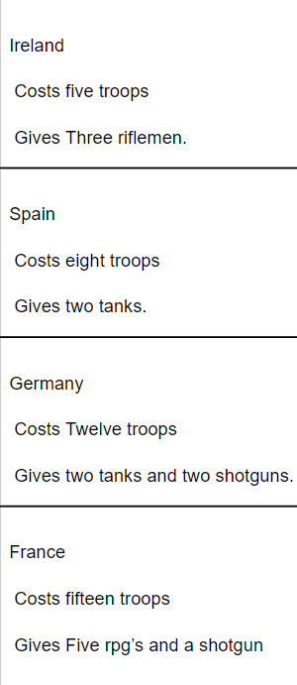

Pen and paper to keep track of how many troops you have.

2.2 Rules

* Players move by rolling a 6-sided dice. If a player rolls a 3, they can move 1, 2, or 3 spaces.
* If you land on an unoccupied tile, you can claim it.
* If you land on an occupied tile, you can choose to battle for that tile.
* If you land on a chance deck, you pick up a card from the chance deck and you could either get a good or a bad card, such as gaining or losing troops.

Battles are fought by using troops.

* The attacking player chooses how many troops they want to put into battle.
* The defender uses their own troops on defence, and they continue to expend troops until one stop.
* Each troop has a value.
* The battle then progresses, and the troops are expended. The winner then keeps the troops they have left over.

1.3 Playtesting

There was no playtesting.

1.4 Discussion

From creating the game, we realised that we would need a way to buy territories, so we decided as a team that we would make each territory cost troops to “guard” each territory and in return, each territory will give you troops during your turn.

1.5 Reflection

The team I had worked with was Danyal Mahmood and Brennon Franklin. What I had learned from making this game is that we need to make sure we know what each teammate is doing because it would mean we know what the each of us are doing and would make progress quicker since we know what each other is doing.